Exercise 1: Generate text embeddings and perform semantic similarity search
Aim
To generate text embeddings and perform semantic similarity search using sentence embeddings.
Explanation
Text embeddings convert text into numerical vectors. Semantically similar sentences have vectors that are close to each other.
Program
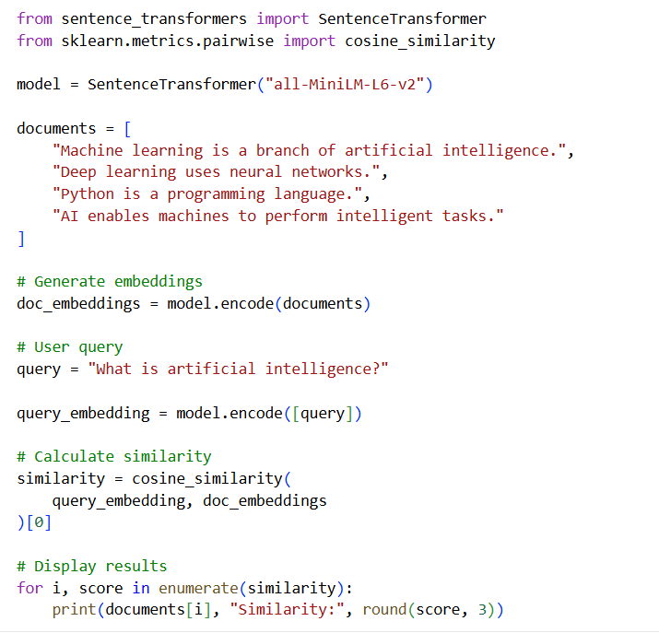
Output:
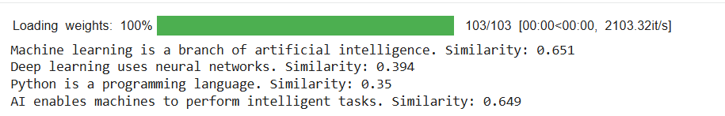
Result: Text embeddings were generated successfully, and semantic similarity search was performed.
Exercise 2: Develop a semantic search system using cosine similarity
Aim
To develop a semantic search system that retrieves relevant documents using cosine similarity between query and document embeddings.
Explanation
Cosine similarity measures the similarity between two vectors.
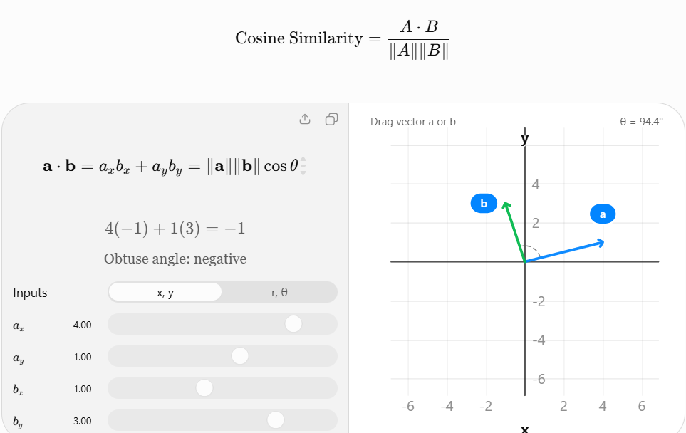
A higher cosine similarity score indicates greater similarity between the query and document.

Program
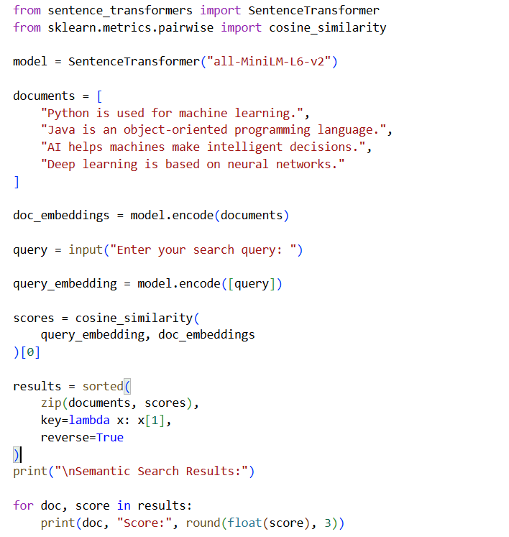
Output:
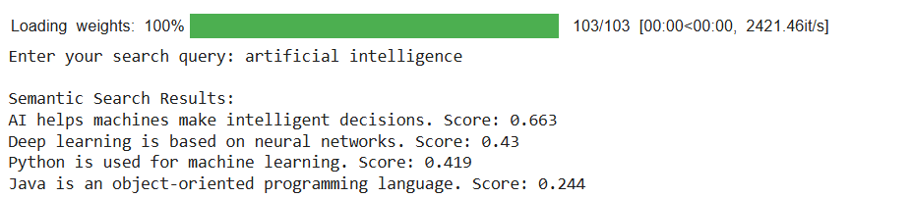
The actual similarity scores are generated by the model.
Result: A semantic search system using cosine similarity was implemented successfully.

Exercise 3: Build a vector database using FAISS or ChromaDB
Aim
To build a vector database using FAISS and perform similarity-based document retrieval.
Explanation
FAISS is a library developed for efficient similarity search and clustering of vectors. It stores embeddings and retrieves similar vectors efficiently.
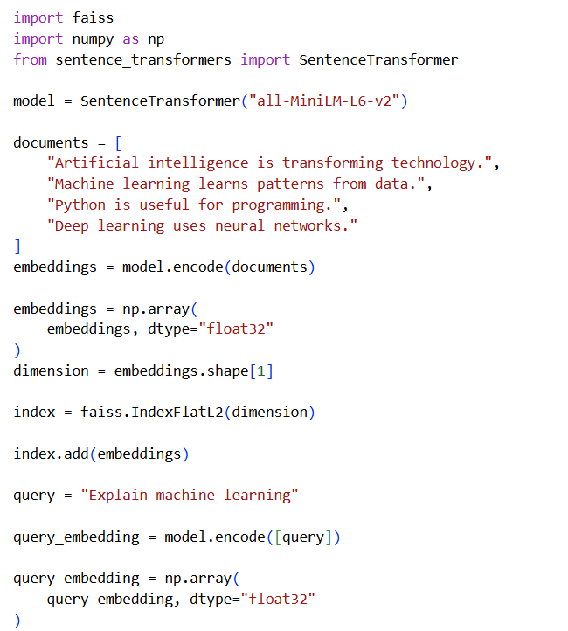
Program using FAISS

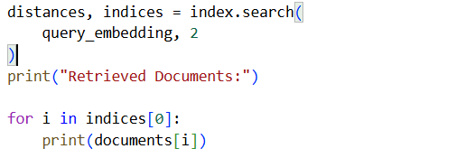

Output:
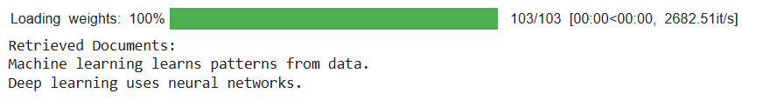
Result: A FAISS vector database was created and used for similarity-based retrieval.
Exercise 4: Implement document storage and top-k retrieval using a vector database
Aim
To store documents in a vector database and retrieve the top-k most relevant documents.
Explanation
Top-k retrieval returns the k documents with the highest similarity to a query.
For example, if k = 3, the system returns the three most relevant documents.
Program
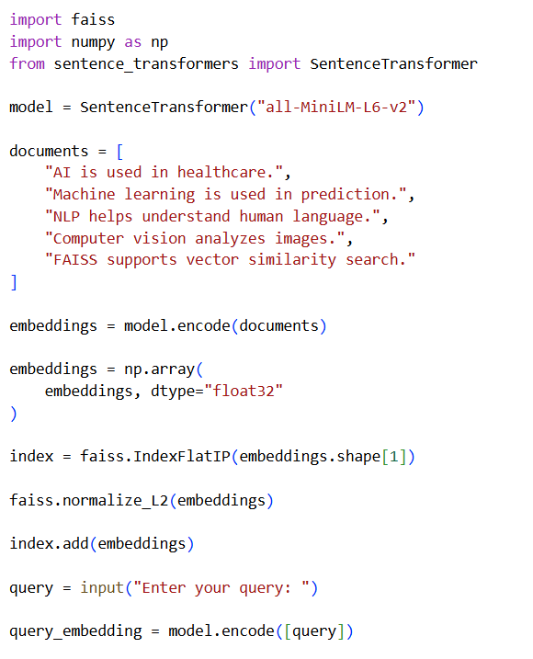

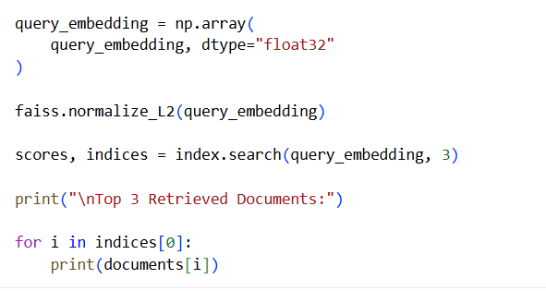
Output:
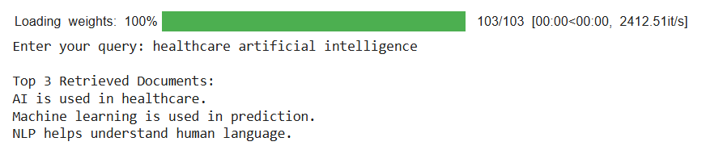
Result: Documents were stored in FAISS, and top-k retrieval was implemented successfully.
Exercise 5: Develop a document Question Answering system using RAG
Aim
To develop a Question Answering system using Retrieval-Augmented Generation (RAG).
Explanation
RAG combines document retrieval with language generation.


Program
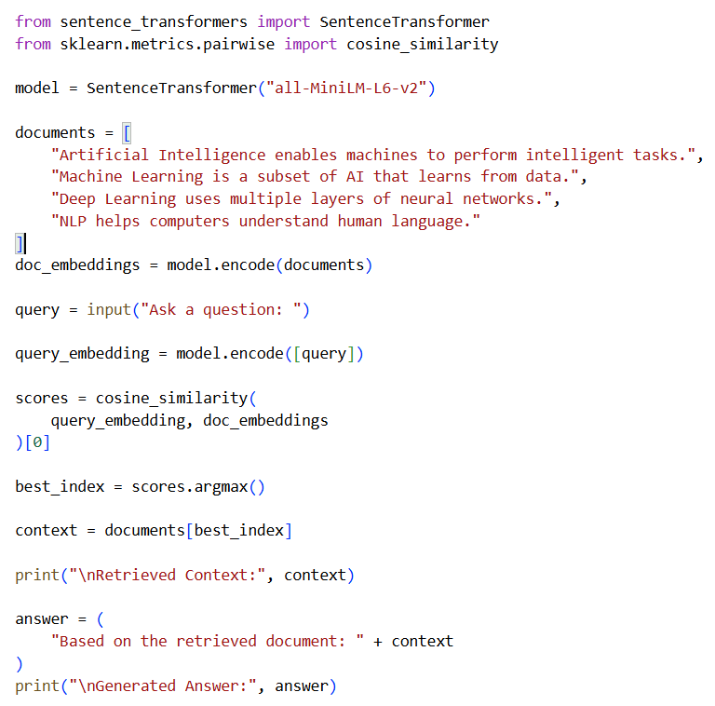
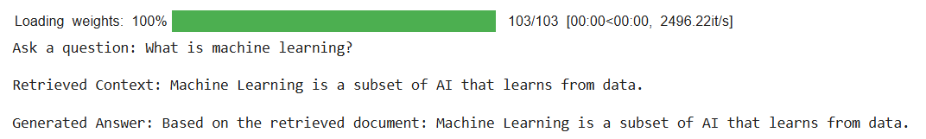
Output:

Result: A basic document-based Question Answering system was implemented using RAG principles.

Exercise 6: Build an end-to-end RAG pipeline
Aim
To build an end-to-end RAG pipeline involving document loading, text chunking, embeddings, retrieval, and answer generation.
Steps
- Load documents.
- Split documents into chunks.
- Generate embeddings.
- Store embeddings in FAISS.
- Retrieve relevant chunks.
- Generate answers using an LLM.
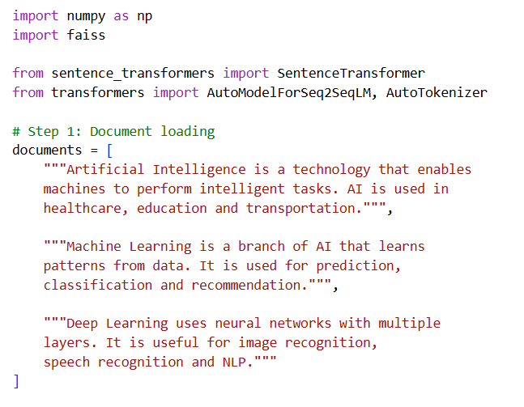
Program

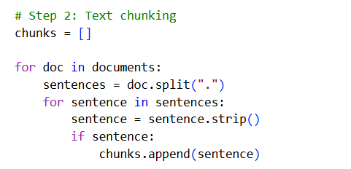
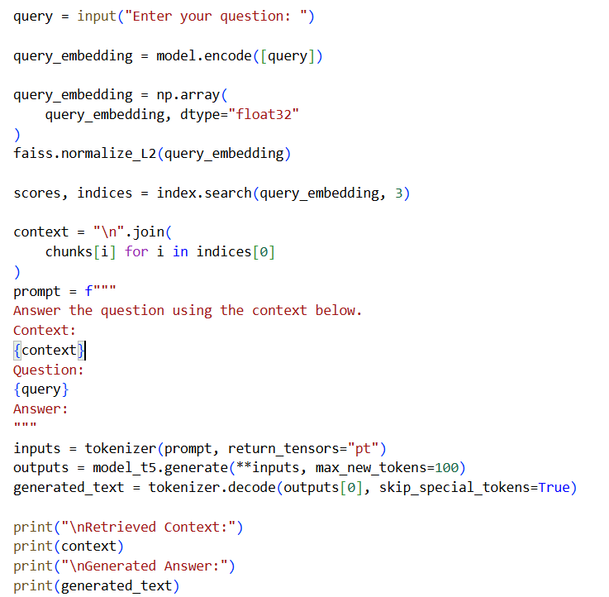
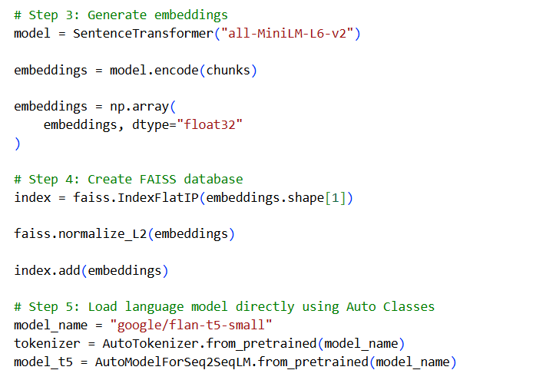

Output:
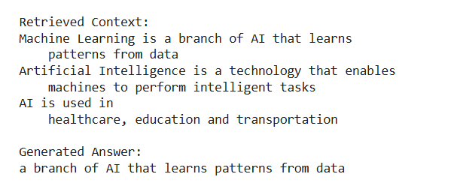
Result: An end-to-end RAG pipeline was implemented successfully
Exercise 7: Develop a domain-specific chatbot using LangChain and a vector database
Aim
To develop a chatbot that answers questions related to a specific domain using LangChain and ChromaDB.
Domain
Artificial Intelligence
Explanation
A domain-specific chatbot answers questions within a particular subject area using stored documents.
Program
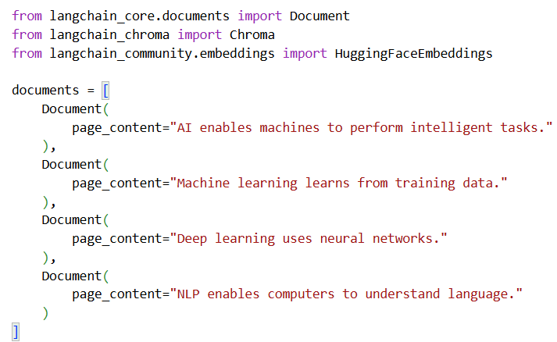
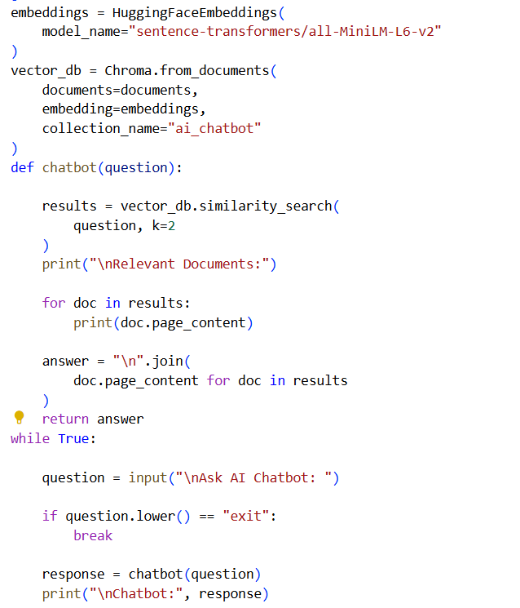
Output:
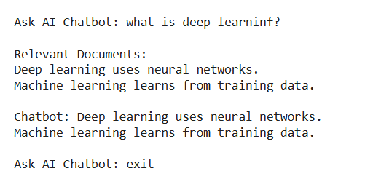

Exercise 8: Implement a context-aware chatbot using LangChain, retrieval, and an LLM
Aim
To implement a context-aware chatbot that retrieves relevant information and generates answers using an LLM.
Explanation
A context-aware chatbot uses previous conversation history and retrieved documents to generate more relevant answers.
Program
This exercise uses LangChain, ChromaDB, and a Hugging Face language model.
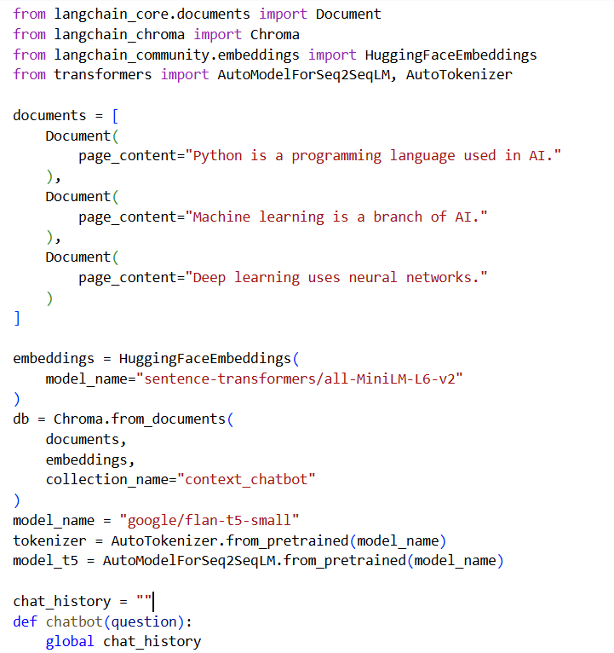

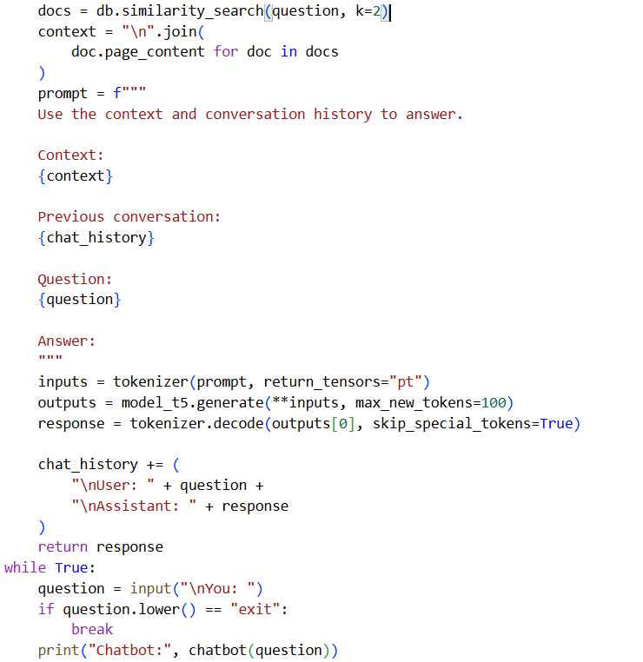
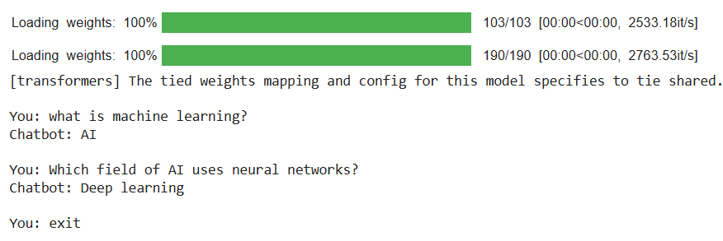
Output:
Result: A context-aware chatbot was implemented using LangChain, retrieval, and an LLM.

Exercise 9: Develop a simple AI assistant using external documents
Aim
To develop an AI assistant capable of answering questions using external documents.
Explanation
The AI assistant loads an external text file, converts its content into embeddings, retrieves relevant information, and answers user questions.
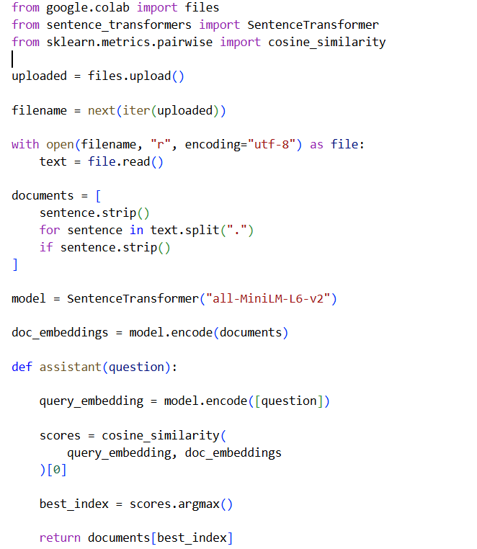
Program

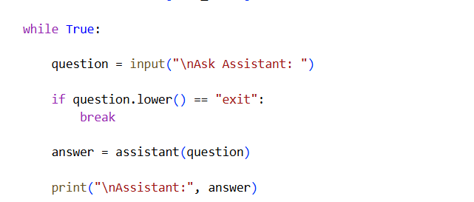

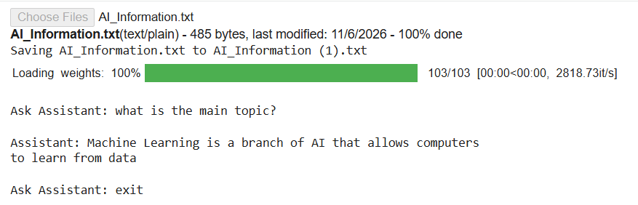
Output:
Result: An AI assistant capable of answering questions using external documents was developed.
Exercise 10: Build a document-based AI assistant supporting multiple uploaded documents
Aim
To build an AI assistant that supports multiple uploaded documents and question answering.
Explanation
This system allows users to upload multiple documents. It combines the document contents, generates embeddings, and retrieves the most relevant information for a question.
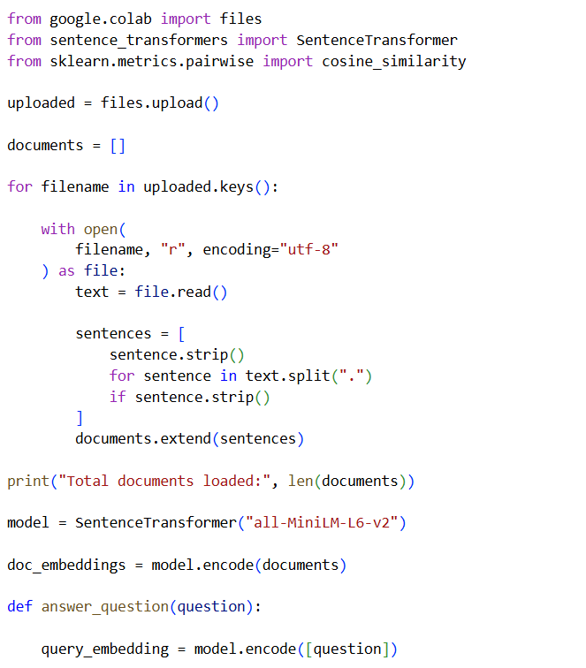
Program

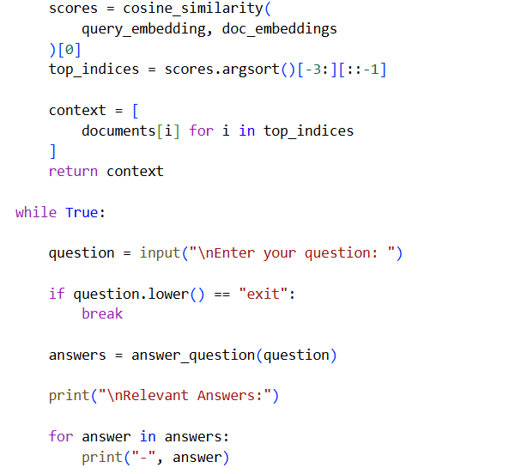
Output:
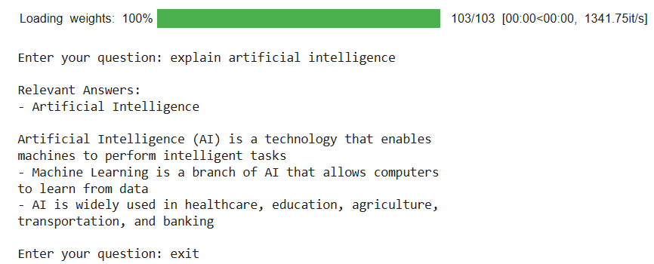
Result: A document-based AI assistant supporting multiple uploaded documents and question answering was implemented successfully.

